One-Line Diagrams
Norbert Doerry
April 8, 2026
- Introduction
U.S. Coast Guard Marine Safety Center Procedure Number E2-07 states …
“The purpose of an electrical one-line diagram is to provide an elementary schematic outlining connections from power sources (generators, shore power, battery banks) through a distribution system (switchboard, busbars, cables, feeders, and panels) to supply various power consuming loads.”
The one-line diagram may incorporate additional information such as that required by 46CFR110.25 to include:
- Type and size of generators and prime movers.
- Type and size of generator cables, bus-tie cables, feeders, and branch circuit cables.
- Power and lighting panelboards with number of circuits and rating of energy consuming devices.
- Type and capacity of storage batteries.
- Rating of circuit breakers and switches, interrupting capacity of overcurrent devices, and rating or setting of overcurrent devices.
- Location (machinery room) of electrical equipment.
The lines representing the connections in a one-line diagram represent the power cables (or bus duct / bus pipe) connecting equipment; the cables can contain multiple conductors, and multiple cables may be paralleled. For this reason, a one-line diagram is more like a network diagram rather than a wiring diagram.
The level of detail provided in a one-line diagram depends on the stage of design and the needs of analyses being conducted during the stage of design; more detail is provided as the design matures. Figure 1 depicts a one-line diagram typical of preliminary and contract design for a ship with a zonal electrical distribution system. In this case, the electrical distribution is only shown to the level of the load center. Other more detailed drawings would be expected to depict the connection of individual loads (perhaps through power panels) to the load centers. Figure 2 depicts a one-line diagram typical of early concept studies for a notional commercial ship (cruise ship in this case). Note that while all the appropriate equipment and connectivity are shown, certain details provided in Figure 1 are not depicted. Note that in Figure 2 for example, all of the low voltage (450 volts or less) loads are lumped together; during later stages of design, the low voltage distribution system would be more fully defined. To enhance clarity, a one-line diagram may span multiple drawing sheets.
For detail design, ABS MVR for example, requires a one line diagram of main and emergency power distribution systems that shows:
- “Generators: kW rating, voltage, rated current, frequency, number of phases, power factor.
- Motors: kW or hp rating, voltage and current rating, remote stops (when required).
- Motor controllers: type (direct-on-line, star-delta, etc.), disconnect devices, overload and under-voltage protections, remote stops, as applicable.
- Transformers: kVA rating, rated voltage and current, winding connection.
- Circuits: designations, type and size of cables, trip setting and rating of circuit protective devices, rated load of each branch circuit, emergency tripping and preferential tripping features.
- Batteries: type, voltage, rated capacity, conductor protection, charging and discharging boards.”
The one-line diagram and the electrical power system concept of operations (EPS-CONOPS) are used together to define the ship’s electrical power system architecture and how the electrical power system is intended to be operated. This information is used by the various analyses performed in ship design to include the Electric Power Load Analysis (EPLA).
One-line diagrams may also be called “single line diagrams.”
Figure 1: USS Makin Island (LHD 8) one-line diagram (Dalton et al. 2002)
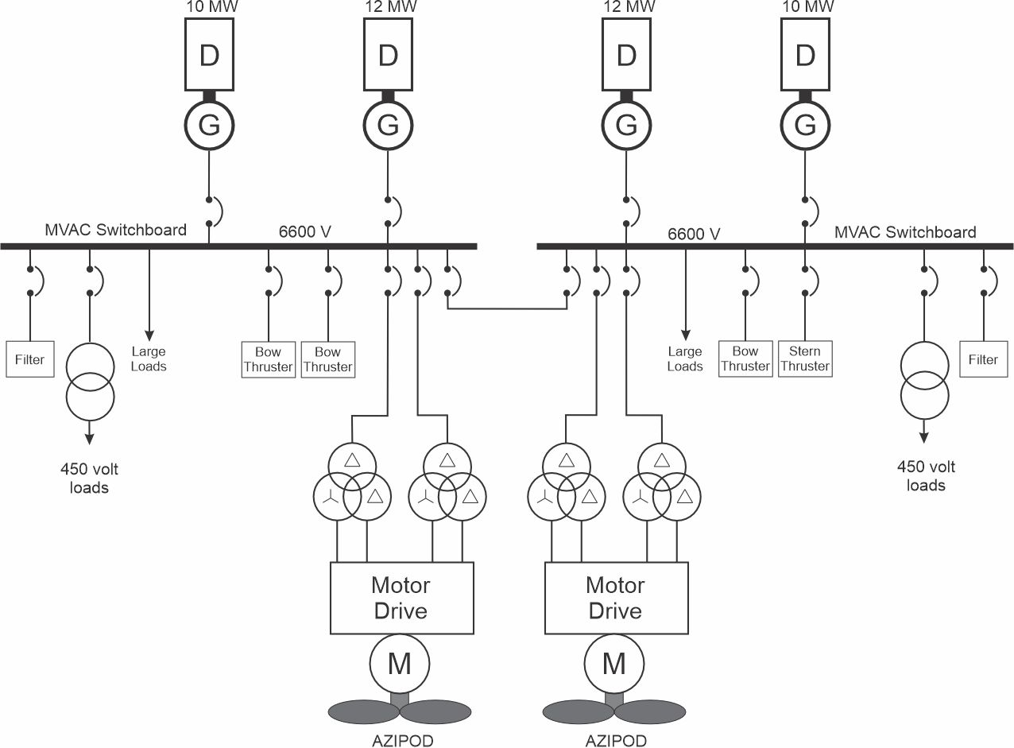
Figure 2: Typical cruise ship one-line diagram
- One-line diagram guidance
  - Symbols
The symbols used on one-line diagrams are not standardized; one will encounter a variety in practice. Ideally, a one-line diagram should include a legend defining the symbols used. Often a box with an appropriate label is used to represent a particular piece of equipment that doesn’t have a customarily used symbol. Figures 3-14 depict many symbols one may encounter in one-line diagrams.
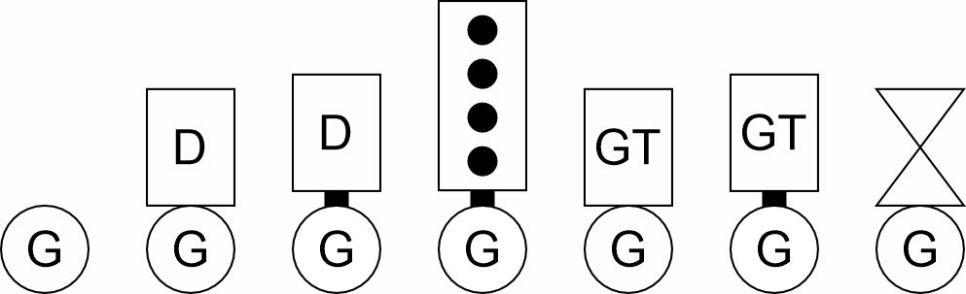
(a) (b) (c) (d) (e) (f) (g)
Figure 3: Generator set symbols: (a) Generator; (b) (c) (d) Diesel generator sets; (e) (f) (g) Gas turbine generator sets
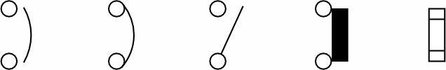
(a) (b) (c) (d) (e)
Figure 4: Circuit interrupter symbols: (a) (b) Circuit breakers; (c) Disconnect switch; (d) Fused disconnect switch (e) Fuse
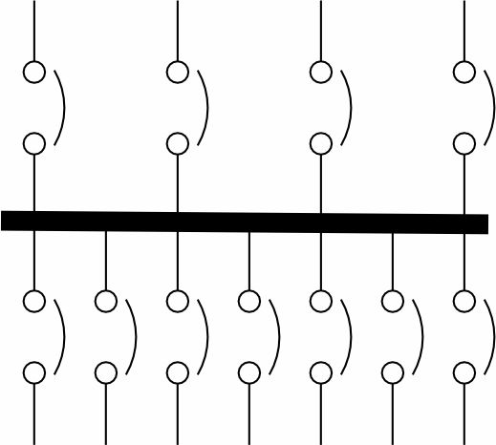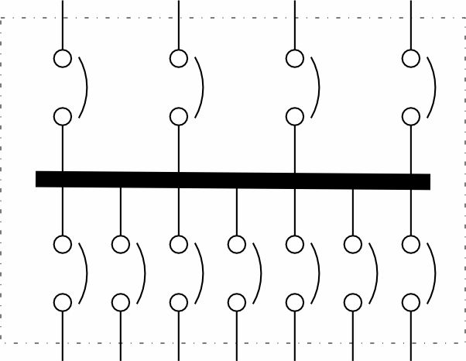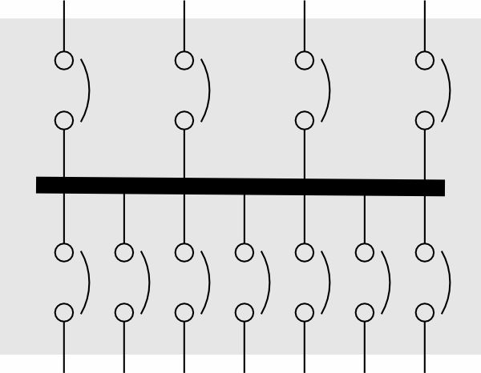
(a) (b) (c)
Figure 5: Switchboards, load centers, and power panels (a) (b) (c)
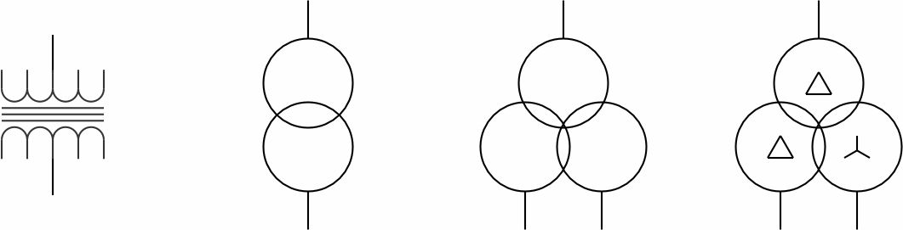
(a) (b) (c) (d)
Figure 6: Transformers: Two sets of windings (a) (b); Three sets of windings (c) (d)
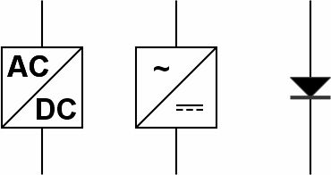
(a) (b) (c)
Figure 7: Rectifier (a) (b) (c)
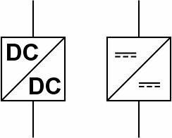
(a) (b)
Figure 8: DC to DC converter (a) (b)
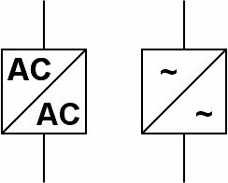
(a) (b)
Figure 9: AC to AC converter (a) (b)
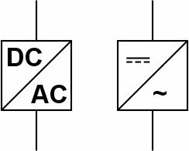
(a) (b)
Figure 10: Inverter (a) (b)
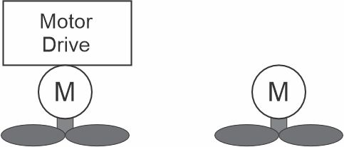
(a) (b)
Figure 11: Propulsion Motor: (a) with motor drive (b) without motor drive
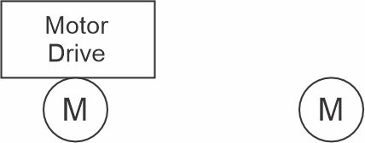
(a) (b)
Figure 12: Motor (a) with motor drive (b) without motor drive
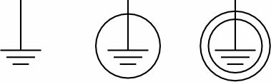
(a) (b) (c)
Figure 13: Grounding / Earthing: (a) System ground (b) Equipment ground – protective earth (c) common mode ground
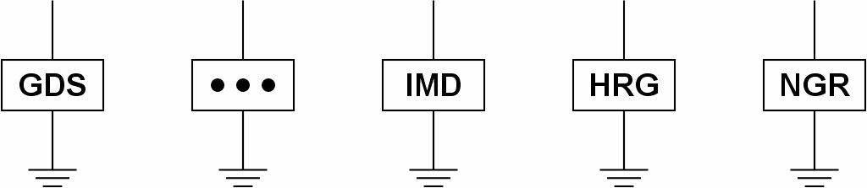
(a) (b) (c) (d) (e)
Figure 14: Grounding equipment: (a) Ground detection system (b) Ground detection lamps (c) Insulation monitoring device (d) High resistance ground system (e) Neutral grounding resistor
  - Layout
While there is no standard defining the layout of a one-line diagram, certain conventions are commonly employed:
- Multiple sheets may be employed to improve clarity. If a line is intended to represent a connection to a particular piece of equipment (such as a transformer, load center, or power panel) on another sheet, then the circuit breaker, if present in the design, is shown in the associated switchboard (load center or power panel). Text at the end of the line should include a unique identifier that indicates the proper connection to the other sheet. See Herbert Engineering Corp (2016) for a multi-sheet one-line diagram.
- The main power generation and distribution system to the switchboard level (and possibly to the load center level) is typically depicted on one sheet.
  - If a traditional two-switchboard power system similar to Figure 2 is employed, then the generator sets are usually depicted on top, followed by the switchboards, with the loads at the bottom. The port switchboard is depicted on the left, and the starboard switchboard is depicted on the right. Where possible, equipment should be arranged so that equipment in the same space are near each other. Many times, dotted or dashed lines are used to depict space boundaries.
  - If a zonal power system similar to Figure 1 is employed, then the equipment is usually arranged by zone, with the forward most zone on the right, and the aft most zone on the left. Many times, dotted or dashed lines are used to depict the zone boundaries.
- Additional sheets may be employed to depict distribution below the switchboard (load center) level.
- If a line is intended to represent multiple connections to multiple loads (a proxy load for example), then the connection to the switchboard (load center, power panel) usually does not include a circuit breaker symbol; each load connection is understood to have its own circuit breaker. Text at the end of the line should include a description of the loads connected via this line.
- The first sheet should include a legend to describe the symbols used.
  - Level of detail to support EPLA
The following guidance is recommended for developing a one line diagram to support performing an EPLA
- The electrical distribution system should be defined to the load center level (or the switchboard level if the design does not include load centers). This facilitates assigning loads from the load list to the appropriate load center.
- All power system equipment should have a unique identifier. The unique identifier helps ensure that the EPS-CONOPS refers to the appropriate electrical power system component.
- All bus-tie circuit breakers, generator circuit breakers, circuit breakers associated with energy storage, circuit breakers supplying large transformers / power conversion equipment, circuit breakers supplying switchboards and circuit breakers supplying load centers should have a unique identifier. The trip rating for these circuit breakers should be depicted if known. The unique identifier helps ensure that the EPS-CONOPS refers to the appropriate electrical power system component; the configuration of the electric plant for each operating condition can be defined without ambiguity. Listing the trip rating can help ensure the circuit breakers are appropriately rated based on load flow analysis.
- The cable type, cable number, and ampacity should be depicted for all cables connecting generator sets to the power system, energy storage systems to the power system, bus-ties, large transformers and large power electronic converters, and large loads. If known, one should consider depicting the length of the cable. This information is useful for modeling the cables in a load flow analysis.
- For generator sets, the kW rating, kVA rating (or rated power factor), voltage, frequency, and number of phases should be depicted. This information helps ensure sufficient but not excessive generator set capacity is installed.
- For transformers, the kW rating, kVA rating (or rated power factor), primary voltage, secondary voltage should be depicted. This information helps ensure sufficient but not excessive transformer capacity is installed.
- For energy storage, the charge rate, discharge rate, voltage rating, and energy rating should be depicted. This information helps ensure sufficient but not excessive energy storage capacity is installed.
- All large loads should have a unique identifier and the one line diagram should depict the kW connected load, and the kVA connected load (or rated power factor). The unique identifier helps to ensure the proper load configurations are specified in the EPLA for each operating condition. The connected load helps ensure cables and other power system equipment have sufficient capacity to serve these loads.
- References
ABS MVR, ABS Rules for Building and Classing Marine Vessels
Code of Federal Regulations, “Coast Guard, Department of Homeland Security – Electrical Engineering - Plans and information required for new construction, 46CFR110.25.
U.S. Coast Guard Marine Safety Center, Review of Electrical One-Line Diagrams, Plan Review Guideline, Procedure Number E2-07, Revision Date: October 12, 2021. https://www.dco.uscg.mil/Portals/9/MSC/PRG/PRG.E2-07.2021.10.13.Electrical%20One-Line%20Diagram.pdf
Dalton, Thomas, Abe Boughner, C. David Mako, and CDR Norbert Doerry, "LHD 8: A step Toward the All Electric Warship", presented at ASNE Day 2002.
Herbert Engineering Corp., NSMV Phase 3 Design Electrical Single Line Diagrams," Document 2015-017-03-30, Prepared for U.S. Maritime Administration, Last update December 8, 2016.

